T. Y. B. Tech (Computer Science and Business System
Academic Year – 2023-2024 Semester -V
Elective II: [CS3104C]: Cloud, Microservices & Applications
Unit2: Application architectures
Syllabus:
Monolithic & Distributed, Microservice fundamental and design approach, Cloud Native applications-12 Factors App. Application integration process/Amplification Process, API Fundamental. Microservice /API management, Spring boot Fundamental and design of microservice, API tools. Developer Portal. Applications of Microservice

Monolithic architecture is built as one large system and is usually one code-base. Monolithic application is tightly coupled and entangled as the application evolves, making it difficult to isolate services for purposes such as independent scaling or code maintainability.
It extremely difficult to change technology or language or framework because everything is tightly coupled and depend on each other.
Microservices architecture is built as small independent module based on business functionality. In microservices application, each project and services are independent from each other at the code level. Therefore it is easy to configure and deploy completely and also easy to scale based on demand.
Sr. No. | Key | Monolithic architecture | Microservices architecture
1 | Basic | Monolithic architecture is built as one large system and is usually one code-base | Microservices architecture is built as small independent module based on business functionality
2 | Scale | It is not easy to scale based on demand | It is easy to scale based on demand.
3 | Database | It has shared database | Each project and module has their own database
4 | Deployment | Large code base makes IDE slow and build time gets increase. | Each project is independent and small in size. So overall build and development time gets decrease.
5 | Tightly Coupled and Loosely coupled | It extremely difficult to change technology or language or framework because everything is tightly coupled and depend on each other | Easy to change technology or framework because every module and project is independent

MONOLITHIC ARCHITECTURE
The monolithic architecture is considered to be a traditional way of building applications. A monolithic application is built as a single and indivisible unit. Usually, such a solution comprises a client-side user interface, a server side-application, and a database. It is unified and all the functions are managed and served in one place.
Normally, monolithic applications have one large code base and lack modularity. If developers want to update or change something, they access the same code base. So, they make changes in the whole stack at once.

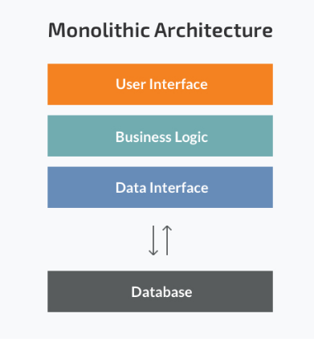 Strengths of the Monolithic Architecture
- Less cross-cutting concerns. Cross-cutting concerns are the concerns that affect the whole application such as logging, handling, caching, and performance monitoring. In a monolithic application, this area of functionality concerns only one application so it is easier to handle it.
- Easier debugging and testing. In contrast to the microservices architecture, monolithic applications are much easier to debug and test. Since a monolithic app is a single indivisible unit, you can run end-to-end testing much faster.
- Simple to deploy. Another advantage associated with the simplicity of monolithic apps is easier deployment. When it comes to monolithic applications, you do not have to handle many deployments – just one file or directory.
- Simple to develop. As long as the monolithic approach is a standard way of building applications, any engineering team has the right knowledge and capabilities to develop a monolithic application.

Weaknesses of the Monolithic Architecture
- Understanding. When a monolithic application scales up, it becomes too complicated to understand. Also, a complex system of code within one application is hard to manage.
- Making changes. It is harder to implement changes in such a large and complex application with highly tight coupling. Any code change affects the whole system so it has to be thoroughly coordinated. This makes the overall development process much longer.
- Scalability. You cannot scale components independently, only the whole application.
- New technology barriers. It is extremely problematic to apply a new technology in a monolithic application because then the entire application has to be rewritten.

MICROSERVICES ARCHITECTURE
While a monolithic application is a single unified unit, a microservices architecture breaks it down into a collection of smaller independent units. These units carry out every application process as a separate service. So all the services have their own logic and the database as well as perform the specific functions.
Within a microservices architecture, the entire functionality is split up into independently deployable modules which communicate with each other through defined methods called APIs (Application Programming Interfaces). Each service covers its own scope and can be updated, deployed, and scaled independently.
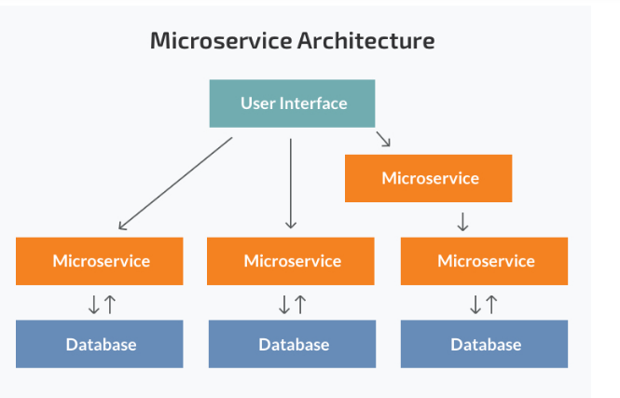

Strengths of the Microservice Architecture
- Independent components. Firstly, all the services can be deployed and updated independently, which gives more flexibility. Secondly, a bug in one microservice has an impact only on a particular service and does not influence the entire application. Also, it is much easier to add new features to a microservice application than a monolithic one.
- Easier understanding. Split up into smaller and simpler components, a microservice application is easier to understand and manage. You just concentrate on a specific service that is related to a business goal you have.
- Better scalability. Another advantage of the microservices approach is that each element can be scaled independently. So the entire process is more cost- and time-effective than with monoliths when the whole application has to be scaled even if there is no need in it. In addition, every monolith has limits in terms of scalability, so the more users you acquire, the more problems you have with your monolith. Therefore, many companies, end up rebuilding their monolithic architectures.
For instance, our partner Currencycloud needed to migrate to microservices due to the growing number of transactions their platform processed. Founded in 2012, the company offers a global B2B payments platfrom. Initially, their monolithic architecture could handle the number of transactions they had. Yet with the company’s growing success, they needed a more efficient solution they could scale even further in the future. So they have switched to microservices.
- Flexibility in choosing the technology. The engineering teams are not limited by the technology chosen from the start. They are free to apply various technologies and frameworks for each microservice.
- The higher level of agility. Any fault in a microservices application affects only a particular service and not the whole solution. So all the changes and experiments are implemented with lower risks and fewer errors.

Weaknesses of the Microservice Architecture
- Extra complexity. Since a microservices architecture is a distributed system, you have to choose and set up the connections between all the modules and databases. Also, as long as such an application includes independent services, all of them have to be deployed independently.
- System distribution. A microservices architecture is a complex system of multiple modules and databases so all the connections have to be handled carefully.
- Cross-cutting concerns. When creating a microservices application, you will have to deal with a number of cross-cutting concerns. They include externalized configuration, logging, metrics, health checks, and others.
- Testing. A multitude of independently deployable components makes testing a microservices-based solution much harder.

SO WHICH SOFTWARE ARCHITECTURE SUITS YOUR SOLUTION AND YOUR BUSINESS BEST?

Choosing a monolithic architecture
- Small team. If you are a startup and your team is small, you may not need to deal with the complexity of the microservices architecture. A monolith can meet all your business needs so there is no emergency to follow the hype and start with microservices.
- A simple application. Small applications which do not demand much business logic, superior scalability, and flexibility work better with monolithic architectures.
- No microservices expertise. Microservices require profound expertise to work well and bring business value. If you want to start a microservices application from scratch with no technical expertise in it, most probably, it will not pay off.
- Quick launch. If you want to develop your application and launch it as soon as possible, a monolithic model is the best choice. It works well when you aim to spend less initially and validate your business idea.

Choosing a microservices architecture
- Microservices expertise. Without proper skills and knowledge, building a microservice application is extremely risky. Still, just having the architecture knowledge is not enough. You need to have DevOps and Containers experts since the concepts are tightly coupled with microservices. Also, domain modelling expertise is a must. Dealing with microservices means splitting the system into separate functionalities and dividing responsibilities.
- A complex and scalable application. The microservices architecture will make scaling and adding new capabilities to your application much easier. So if you plan to develop a large application with multiple modules and user journeys, a microservice pattern would be the best way to handle it.
- Enough engineering skills.

- Since a microservice project comprises multiple teams responsible for multiple services, you need to have enough resources to handle all the processes.
For example, one of our clients, a Fortune 100 company, partnered with N-iX to scale their solution. They built the logistics platform to improve the logistics between its 400+ warehouses in over 60 countries. Yet, after the solution was used for several months, it appeared to be ineffective. It was hard for them to add new functionality and scale the monolithic platform. And scaling was essential as our client has many factories, warehouses, and suppliers, as well as a lot of raw materials and finished goods, which circulate among them. Although our partner had a vision that they needed to migrate to microservices, they did not have the comprehensive in-house expertise to address multiple technical issues and make the platform more efficient and scalable.
The core reason why the platform was not scalable and inefficient was its monolithic architecture. Therefore, our Solution Architect designed and presented a new cloud-native infrastructure of the platform based on Azure Kubernetes, along with the suggested tech stack and the most efficient roadmap.

